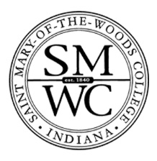
Gainful Employment Disclosures – 2019
Saint Mary-of-the-Woods College

Program Name: Certificate Music Therapy Equivalency
This program is designed to be completed in 64 weeks.
This program will cost $19,465 if completed within normal time. There may be additional costs for living expenses. These costs were accurate at the time of posting, but may have changed.

Of the students who completed this program within normal time, the typical graduate leaves with $ [XX,XXX] of debt. Fewer than 10 students completed this program within normal time. This number has been withheld to preserve the confidentiality of the students.

Program meets licensure requirements in the following states:
Georgia
Nevada
North Dakota
Oklahoma
Oregon
Rhode Island
Utah (state certification)
Wisconsin (state registry)
License not required in other states.

For more information about graduation rates, loan repayment rates, and post-enrollment earnings about this institution and other postsecondary institutions please click here: https://collegescorecard.ed.gov/

