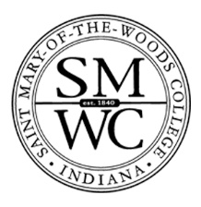
Gainful Employment Disclosures – 2019
Saint Mary-of-the-Woods College

Program Name: Certificate in Paralegal Studies
This program is designed to be completed in 32 weeks.
This program will cost $17,368 if completed within normal time. There may be additional costs for living expenses. These costs were accurate at the time of posting, but may have changed.

Of the students who completed this program within normal time, the typical graduate leaves with $ [XX,XXX] of debt. Fewer than 10 students completed this program within normal time. This number has been withheld to preserve the confidentiality of the students.

The following States do not have licensure requirements for this profession: all states located in the United States.
For more information about graduation rates, loan repayment rates, and post-enrollment earnings about this institution and other postsecondary institutions please click here: https://collegescorecard.ed.gov/

